Why and how could a concept so remote from the real experience of most human beings as national patriotism become such a powerful force so quickly? (Eric Hobsbawm)

Industrial society is the only society ever to live by and rely on sustained and perpetual growth, on an expected and continuous development. Not surprisingly, it was the first society to invent the concept and ideal of progress, of continuous improvement…something unusual must have happened to have engendered so unusual and remarkable an expectation.
Ernest Gellner (Nations and Nationalism)
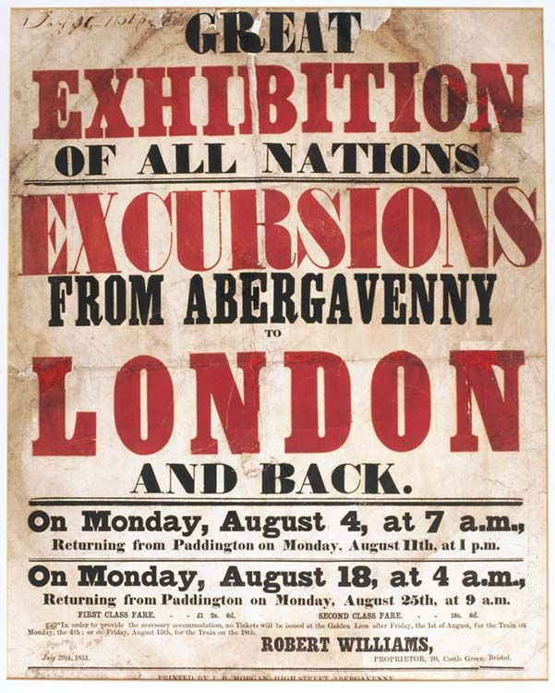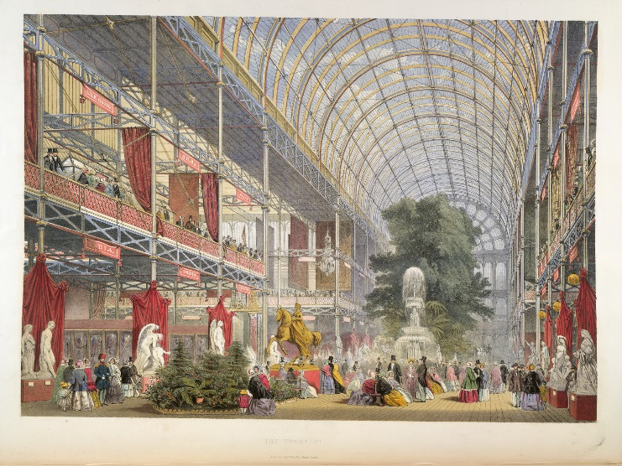
Poster for the Great Exhibition of 1852. This took place in in Hyde Park London. The ‘Crystal Palace’ (above) was built for it. The Great Exhibition displayed the ‘Wonders of Industry and Manufacturing from Around the Modern World.’ 100,000 object were on display. 6 million people visited the exhibition

A society whose entire political system and moral order is based in the last analysis on economic growth and the hope of a perpetual augmentation of satisfactions, whose legitimacy depends upon its capacity to sustain and satisfy this expectation, is thereby committed to the perpetual need for innovation -Ernest Gellner (Nations and Nationalism)
Discussion box one! What are your thoughts so far on Hobsbawm’s big question? Write them here!

At the base of the modern social order stands not the executioner but the professor. The monopoly of legitimate education is now more important to the state, more central than the monopoly of legitimate violence. When this is understood, then the imperative of nationalism, its roots not in human nature, but in a certain kind of now pervasive social order can be understood…
Ernest Gellner (Nations and Nationalism)
Year | National Literacy % (approximate)
1820 | 50%
1840 | 50%
1870 | 76%
1880 | 80%
1900 | 98%

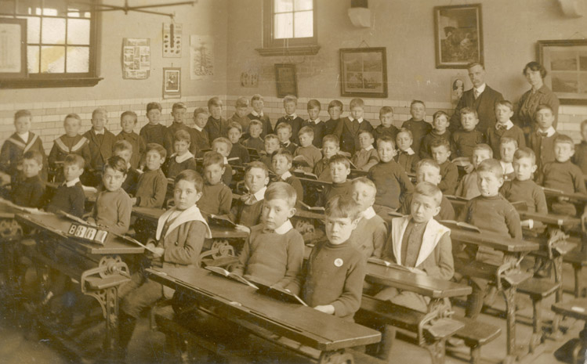
1833 : First government grant for schools for the poor
1844: Education Act: children working in factories were provided with 6 half-days of education each week
1870 Forster Education Act: school boards established to provide education for all children between 5-10. Head teachers now required qualifications. The government built thousnds of new schools
1880 Education Act: School was made compulsory for all children aged 5-10
1893: School age raised to 11
1891: Freed Education Act

Government and subject citizens were inevitably linked like never before with daily contact through the gendarme, the post man and above all, the school teacher. Revolutions in transport and communications, typified the railway and the telegraph system tightened and routinized the links between central authority (government) and its remotest outposts.
Eric Hobsbawm Nations and Nationalism since 1870

Mankind is irreversibly committed to industrial society and therefore to a society based on science and technology. Thus alone can give mankind the kind of standard of living man takes for granted…cultural homogeneity is a prerequisite of industrial society…It is demanded by nationalism -Ernest Gellner, Nations and Nationalism
Naturally states would use the increasingly powerful machinery for communicating with their inhabitants, above all the primary schools, to spread the image and heritage of the ‘nation’ and to inculcate attachment to it and to attach all to country and flag. However, whilst governments were plainly engaged in a conscious and deliberate ideological engineering, it would be a mistake to see these exercises as pure manipulation from above. They were indeed most successful when they built on already present unofficial nationalist sentiments (the root of the word chauvinism and Jingoism appears first in the demagogic music hall or vaudeville)
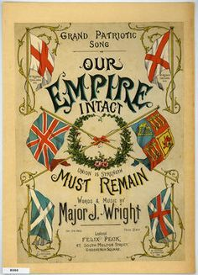
Eric Hobsbawm Nations and Nationalism since 1870
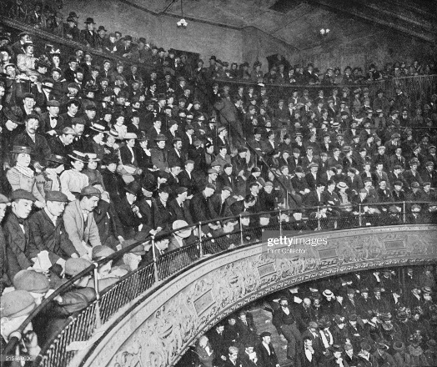
Popular Music Hall ‘Jingo’Songs
1877: ‘By Jingo’
We don’t want to fight
But by Jingo if we do
We’ve got the ships, we’ve got the men, we’ve got the money too.

Popular music hall song sheet 1900
London Music Hall, 1900
We’ve Swept the Seas before Boys’ (sung by ‘Sailor Williams’ at the Oxford Music Hall (London)1871
The Russians threaten war boys
And gather a proud host;
And think the task quite easy
To land on Turkey’s coast;
But let them try it on lads,
They’ll find who rules the main;
We’ve thrashed them well before boys
And so we can again

What is the Meaning of Empire Day?
(sung by schoolchildren on Empire day. 24th May –the day which marked the death of Queen Victoria in 1901.
What is the meaning of Empire Day?
Why do the cannons roar?
Why does the cry ‘God save the King’
Echo from shore to shore
Why does the flag of Britania float
Proudly o’er fort and bay?
Why do our kinsmen gladly hail
Our glorious Empire Day?

For years I have advocated the establishment throughout the empire of a day to be called ‘Empire Day’, on which by state regulation in each portion of the empire, a whole holiday shall be given to all scholars attending schools with the exception of a couple of hours in the mprning, these to be spent by the children in patriotic and agreeable nature, and in listening to lectures and recitations on subjects of an imperialcharacter. I would venture to suggest (that Empire Day be held) on May 24th, the birthday of our late sovereign, Queen Victoria, Emperess of India (Letter by the founder of the Empire Day Movement to the Colonial Secretary, Joseph Chamberlain)

Discussion box two! What are your thoughts so far on Hobsbawm’s big question? Write them here!

Durkheim taught that in religious worship, society adores its own camouflaged image. In a nationalist age, societies worship themselves brazenly and openly, spurning the camouflage.
Ernest Gellner, Nations and Nationalism
Take a look at the wikipedia print out of towns and cities across the world where my name was used
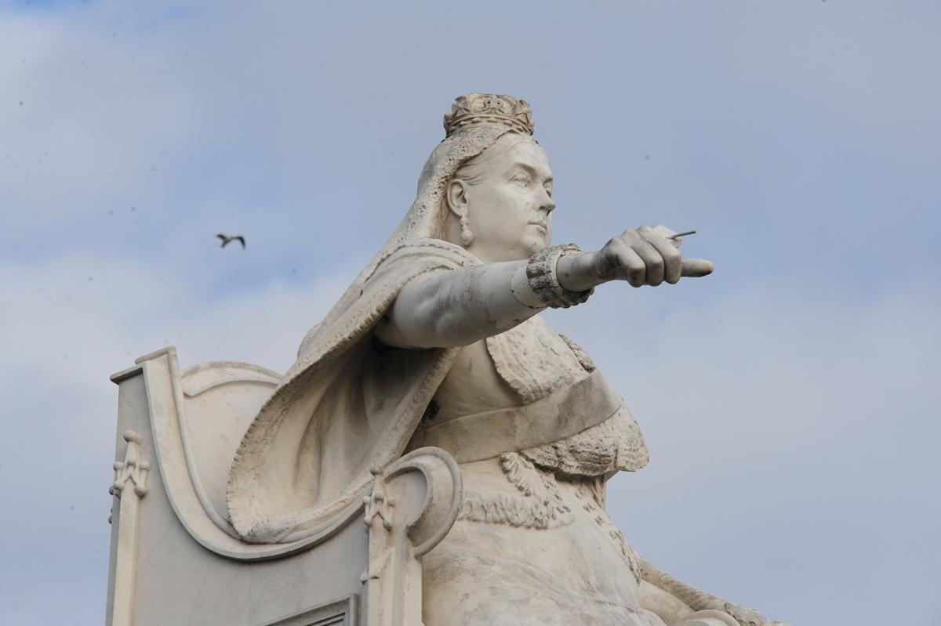
77 statues of Queen Victoria were erected in town centres across Britain in the nineteenth century. Hundreds of streets and squares across the UK also bore the name Victoria.

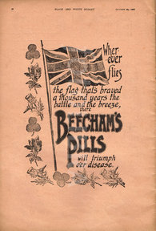
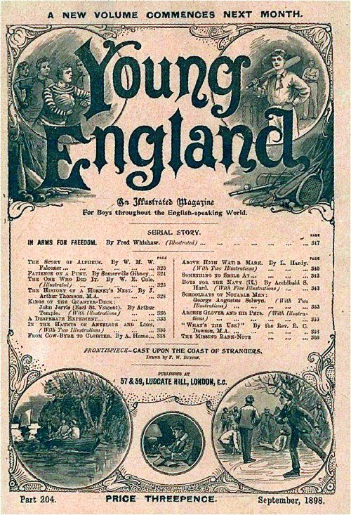

Young England: an illustrated magazine for boys throughout the English Speaking World

Advert (1900) ‘whoever flies the flag that’s braved a thousand years the battle and the breeze…Beecham’s pills will triumph over disease

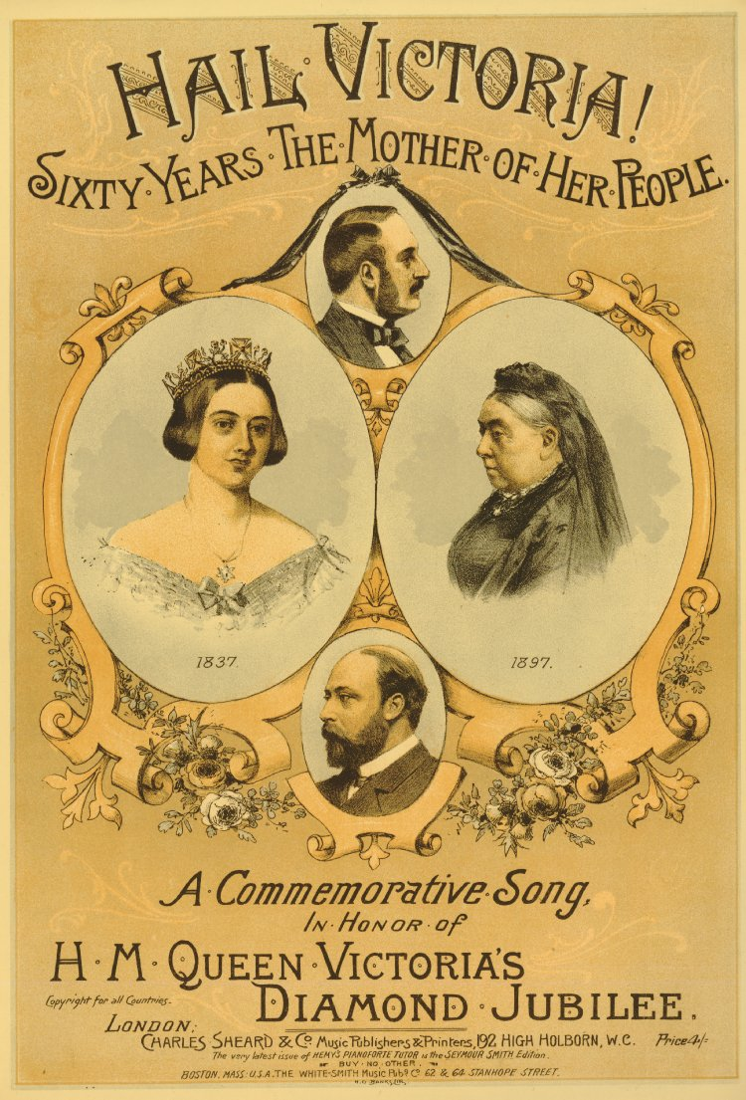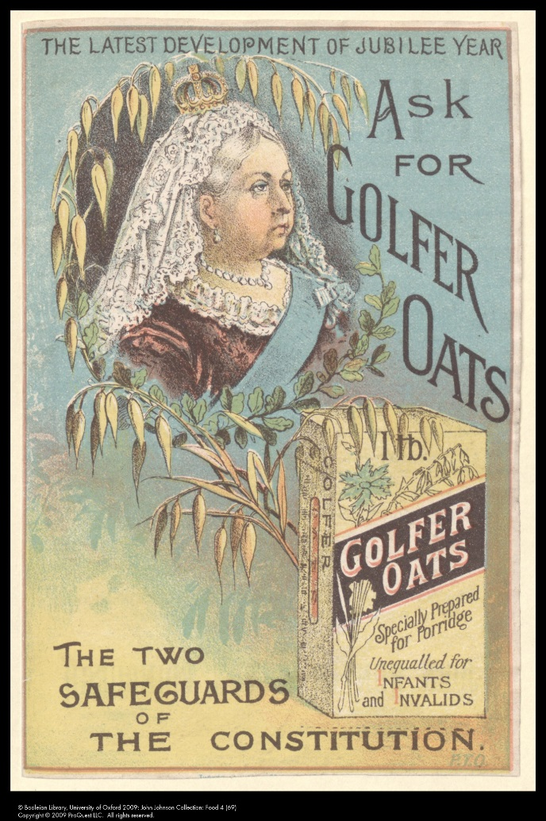
1897

Discussion Box three:What are your thoughts so far on Hobsbawm’s big question? Write them here!

From the 1880s on the debate about the national question becomes serious and intensive, because the political appeal of national slogans to masses of potential or actual voters or supporters of mass political movements was now a matter of practical concern. And the debate on such questions as the theoretical criteria of nationhood became passionate, because any particular answer was now believed to imply a particular form of political strategy, struggle and programme. This a matter of importance not only for governments confronted with various kinds of national agitation, but for political parties seeking to mobilise people on the basis of national appeals
Eric Hobsbawm Nations and Nationalism since 1870

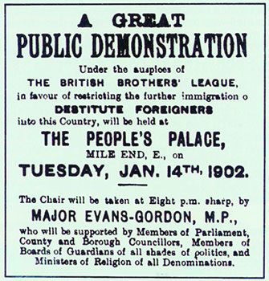

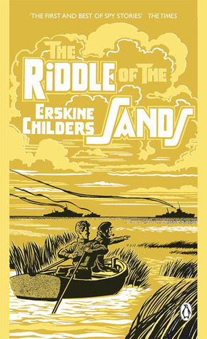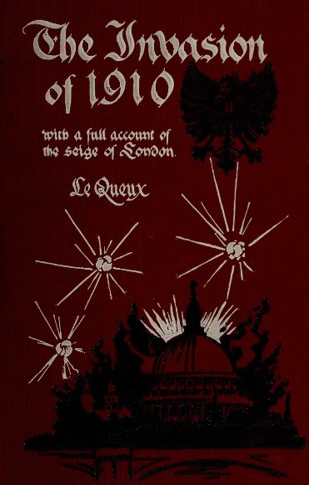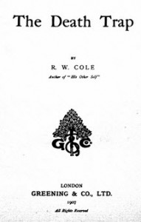
The Riddle of the Sands (1903 novel)- a German invasion plan is uncovered by two young British heroes.

The Death Trap (1907) a novel about a joint invasion of Britain by Germans and Japanese
The Invasion of 1910 : a British best seller novel written in 1906 about an imaginary invasion of Britain by 40,000 Germans

The growing significance of the ‘national question’ in the forty years preceding 1914 is not simply measured by its intensifaction in the old multi-national empires of Austria-Hungary and Turkey. It was now a significant issue in virtually all European states (thus in the UK, the number of newspapers claiming to be national or nationalist rose from 1 in 1871 to 33 in 1891 and became politically explosive in British politics). It is hardly surprising that nationalism gained ground so rapidly from the 1870s to 1914. It was a function of both social and political changes, not to mention an international situation that provided plenty of pegs on which to hang manifestos of hostility to foreigners. Socially, these developments gave considerably increased scope for the development of novel forms of inventing ‘imagined’ or even actual communities as nationalities.
Eric Hobsbawm Nations and Nationalism since 1870.
Why and how could a concept so remote from the real experience of most human beings as national patriotism become such a powerful force so quickly? (Eric Hobsbawm)

Plan your answer here with three or four key words or ideas

Write it here!

