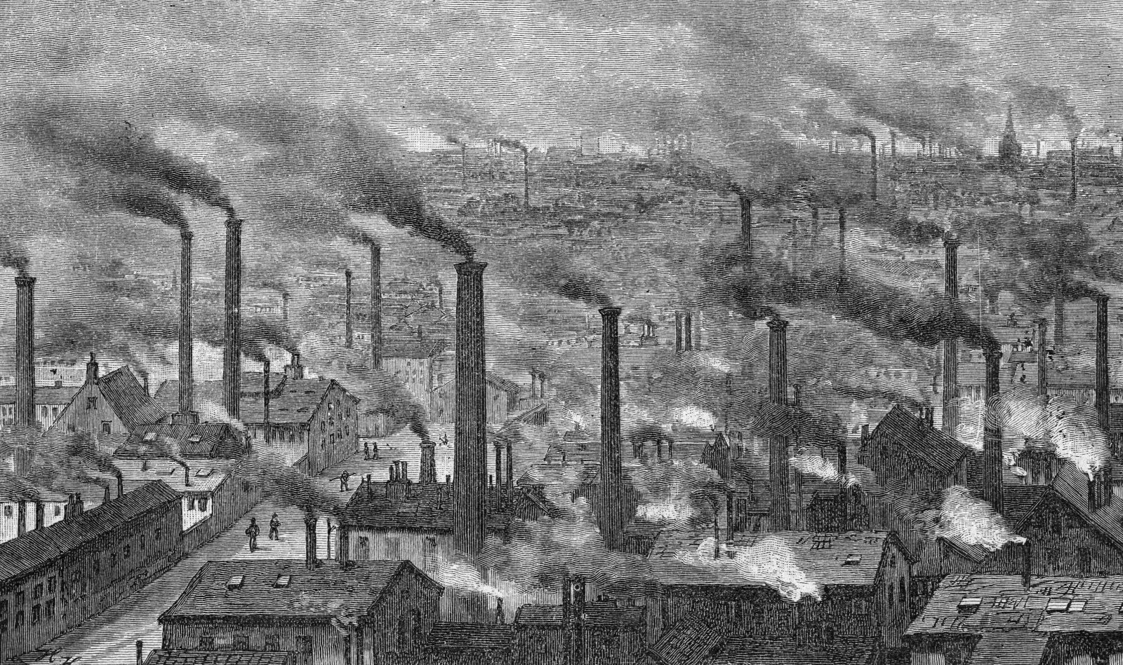

**Modern industry has converted the little workshop in to the great factory of the industrial capitalists. Masses of labourers crowded in to the factory, are organized like soldiers. As privates of the industrial army…not only are they slaves of the bourgeois class and the bourgeois state; they are daily and hourly enslaved by the machine and above all by the individual bourgeois manufacturer himself**



**But with the development of industry, the proletariat not only increases in number, it becomes concentrated in greater masses; its strength grows and it feels that strength more.**



**What the bourgeoisie therefore produces above all, is its own grave diggers. Its fall and the victory of the proletariat are equally inevitable**

**The weapons with which the bourgeoisie felled feudalism are now turned against the bourgeoisie themselves. But not only has the bourgeoisie forged the weapons which bring death unto itself; it has also called in to existence the men who are to wield these weapons –the modern working class –the proletarians**



**The bourgeoisie is unfit to rule because it is incompetent to ensure an existence to its slave within his slavery…society can no longer live under the bourgeoisie, in other words its existence is no longer compatible with society.**



**Modern bourgeois society with its relations of production, of exchange and of property, a society that has conjured up such gigantic means of production and exchange is like the sorcerer who is no longer able to control the powers of the nether world whom he has called up by his spells**



